Official league roster - Basketball
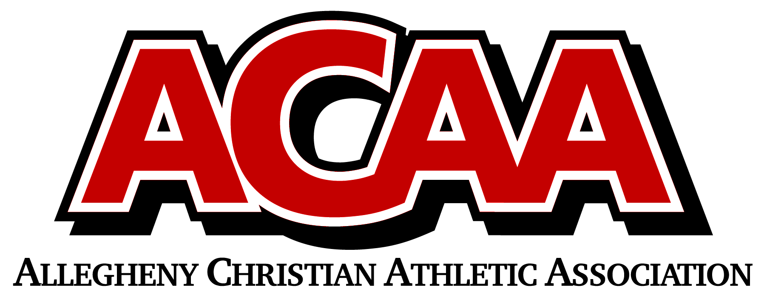

2022-2023

GRACE PREP HIGH SCHOOL
Team Colors: Red, White, Blue Head Coach: Jaquan Masteller
Overall: Wins _____ Losses _____ Ties _____ Asst. Coach: Jeff Koleno
ACAA: Wins _____ Losses _____ Ties _____
Opponent: _________________________________
Number | Name | Year | Position | Height | Homeschool
1 | Asher Costella | 9
2 | Jace Gray | 9
3 | Joseph Brown | 12
4 | Jack Mylin | 10
11 | Bowen Hildebrand | 11
15 | Dane Jones | 12
21 | Tyler Mast | 10
23 | Hayden Foust | 9
43 | Dontae Mast | 11
44 | Alex Byler | 11
45 | Seth Maas | 11
Date: _______________

OFFICIAL ACAA TEAM ROSTER. TO BE SUBMITTED TO THE SCORER’S TABLE BEFORE EACH GAME.

